To See

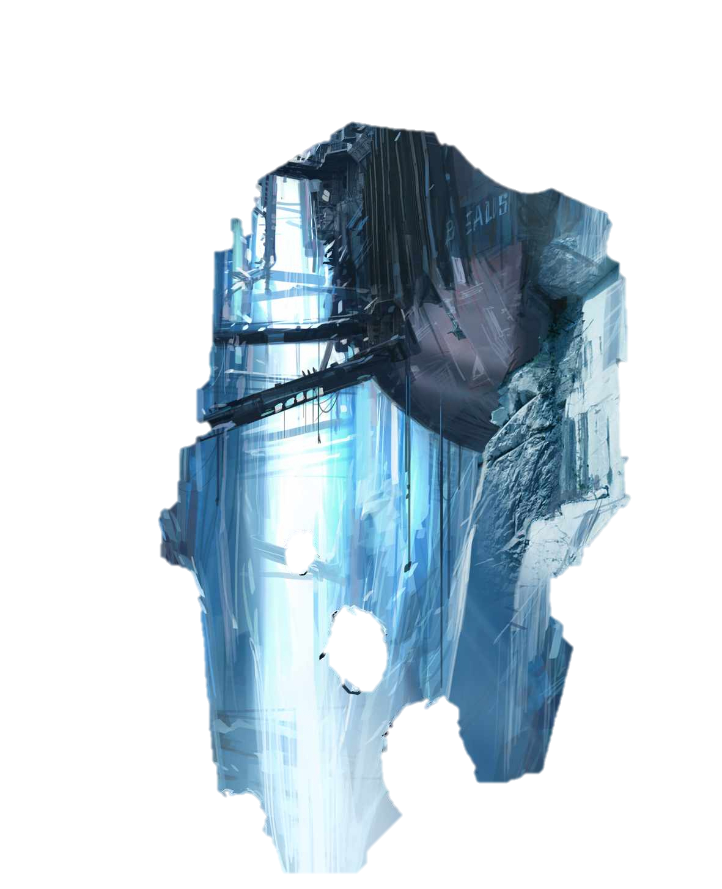
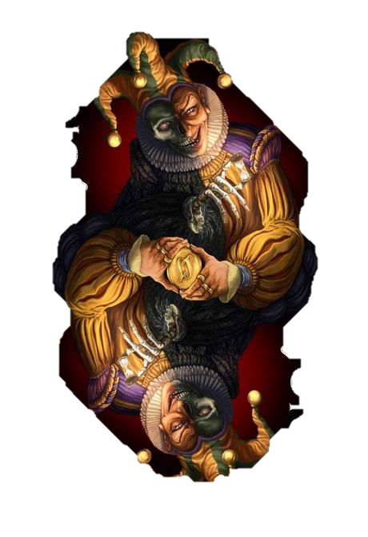
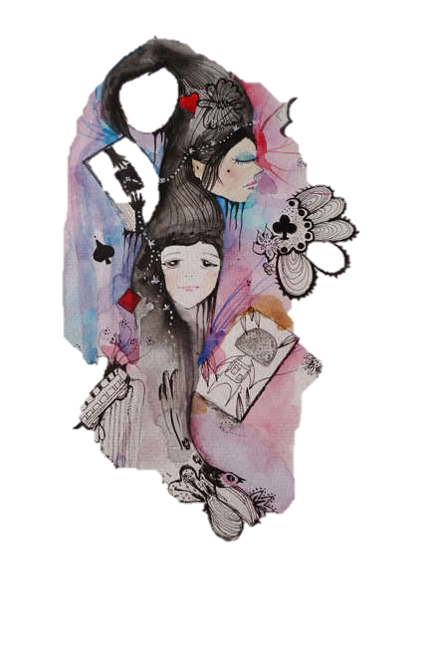
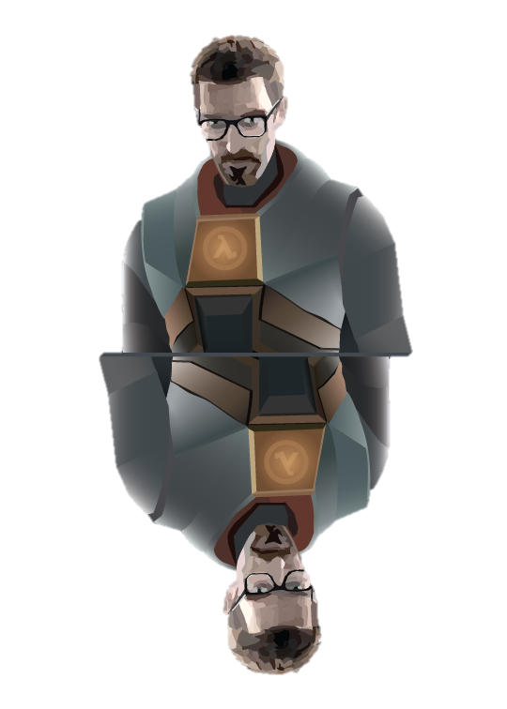

The Cards

Cards

Unlike, procreated cards, we do not use archaic, as of their arcane and traditional esotericism.
This deck will bring Tarot out of the dark closet of occult.

Tarot symbols, images etc., can be interpreted from many points of view.

Tarot is a universal application to anyone, anywhere and anytime.

Tarot, the original meaning of Tarot is not sacrosanct.

Tarot has endured 4000 years since it origin in ancient Egypt.

Tarot core meaning has assumed difficult emphasis over ages.

Tarot strength symbolism is subject to constant redefinition and evolution.

The
Book
Of
Eternity

Master cards and its Life Tree Image
The card is like this tree, as it relates to the universe, earth, growth, upper and lower existence etc.
As it rises to the direction of the Universe and heaven, as it is also the main creation that enables existence of life, as it enables life above and below, it also numbers
7

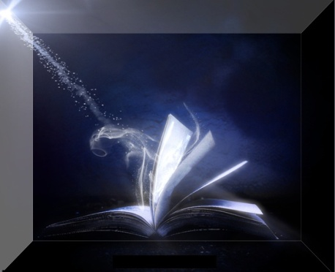

AS It Is
AS It Was

As It Will Be

- Eternity
- Cosmos
- Universe
- Galaxy
- Solar
- Planet
- Infinity

The New Interoperation

Cards

The master exists of 7’s.
Father, Son, Holy Spirit & Humanity.

Multiple like the universes.

Initiated with Father, Son, Spirit & Soul. (4)
Created humanity Man & Woman. (2)
Gave Infinity. (1)
----
7

7 by 4 = 7 7 7 7, Father, Son, Spirit & Soul
7 times multiple of that 4 (Father, Son, Spirit & Soul) = 28
Hence

Then the creation of Man & Woman, that being
created in the image of the Master hence,
Which is above 28 times 2 = 56

Then

Created Infinite, that is = 7

Hence

A collective total of 28
56
7
------ 91

The additional calculation is as below
Total of the cards are 140
Delete the total above 91
--------
49

Wonderfully the 7 is magical
Divide by 49 by 7 = 7
Once again is the Masters number
of
7

The Elements

Cosmos
Sun
Earth
7
Fire
Air
Water
Soul

Tree of Life

